LISTENING
Listen to a radio interview about buying presents.
Write A (Amy), I (Isabelle) or Ch (Charlotte).

Who ...
- … doesn't think the ability to choose good presents is a question of personality?
- … thinks that both men and women can buy good presents?
- … thinks her mother is upset about being forty, so she wants to make her feel happier?
- … says you should be careful when buying women's toiletries?
- … wants to buy a nice expensive gift for one of her school friends?
- … does not have a lot of money to buy a present for a friend?
- … concludes that a good present doesn't have to cost a lot of money?

1 | 2 | 3 | 4 | 5 | 6 | 7

READING
Match the names of holidays in Russia 8-14 with their descriptions in the texts A-G.

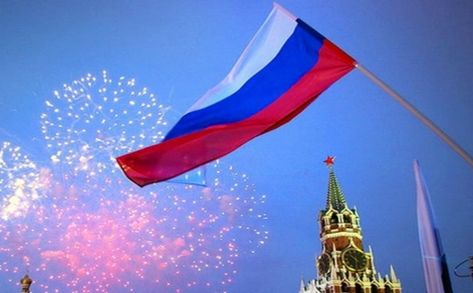
- COSMONAUTICS DAY
- DEFENDERS OF THE FATHERLAND DAY
- INTERNATIONAL WOMEN'S DAY
- PARATROOPERS DAY
- PEOPLE'S UNITY DAY
- RUSSIA DAY
- SPRING AND LABOUR HOLIDAY

A. This day has been an official public holiday in Russia since 2002. Until then it was celebrated as Red Army Day. All men in the USSR had to go to the army, it quickly turned from being a holiday for soldiers to a general “men’s day”—even boys in kindergarten are congratulated on it.
B. Most army units have their own day but you do not notice most of them. If you are in Russia on the day of this army unit you will definitely see that something is being celebrated! Men in army uniforms wave their flags and swim in fountains across the cities.
C. This holiday is new and has only been celebrated since 1994. Originally the holiday was called Day of the Adoption of the Declaration of State Sovereignty of Russia. It is a day of national pride and patriotism, which is also another day-off. Concerts and other celebratory events are often held all over Russia on this day.
D. This is the newest holiday for Russians, celebrated since 2005. It celebrates Kuzma Minin and Prince Dmitri Pozharsky's liberation of Moscow from Poland in 1612 when all classes of Russian society united to protect their country. For the first time in Russian history, ordinary people fought shoulder to shoulder with the aristocracy. Today the day celebrates the idea of togetherness in Russia where more than 160 languages are spoken and where dozens of ethnic groups keep all religions of the world.
E. This holiday in Russia is a day off work. It is a celebration of all women. On this day in Russia, you will see that practically every woman is carrying a bunch of flowers given to her by a male colleague, boss or family member.
F. Russia celebrates this holiday along with another 141 countries. People who grew up in the Soviet Union remember this holiday with nostalgia, because demonstrations of the day were bright events with lots of songs and flowers, every child wanted to go on one. The Russians usually have 4-5 days off to celebrate the holiday, and people use them to go to their dachas and relax in the countryside.
G. On this day in 1961 the first manned space flight set off from Baikonur and successfully orbited the Earth before returning. The man on board was Yuri Gagarin who instantly became a national hero in the Soviet Union. So, this holiday is dedicated to space exploration in general, but most of the focus is usually on Gagarin.

8 | 9 | 10 | 11 | 12 | 13 | 14

VOCABULARY
Fill in the text about Victory Day in Russia with the words from the box.

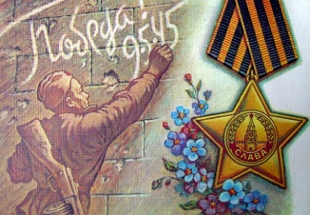
VETERANS OCCASION RELATIVE SO PRACTICALLY PARADES RESPECT FLOWERS SPECTACULAR MEDALS

Victory Day is one of the biggest and most 15. ___________ holidays in Russia. The Second World War, or the Great Patriotic War as it is known in Russia, affected 16. ___________ every Russian family. Today people will recollect how their father, grandfather or great-grandfather reached Berlin, or how a 17. ___________ was killed in action or died at the hands of the Nazis. 18. ___________, it is no surprise that Victory Day remains an important day here and is commemorated with military 19. ___________, fireworks and the laying of 20. ___________ on war graves. It is a time for remembrance but also celebration, and the remaining 21. ___________ put on their 22. ___________ and walk with pride as the younger generations give them flowers and show their 23. ___________. Many also mark the 24. ___________ with their families by telling war stories and singing war songs.

GRAMMAR
Fill in the text about New Year in Russia with the correct forms of the words A, B or C.

How to ring in the New Year like a Russian? If you want 25. ___________ and survive New Year Russian-style, here’s a step-by-step guide.
In Russia, New Year’s occurs 26. ___________ than Christmas (which is celebrated on Jan. 7), so gifts are exchanged on New Year’s. They 27. ___________ in stockings that hang from the fireplace, but rather are carefully arranged under the main holiday tree.
No one knows what 28. ___________ to 29. ___________ parents, but she is Ded Moroz’s granddaughter and she successfully replaces all Christmas elves. In Russian families, this pair entertains young children. Usually in exchange for sweets, children have to stand on a chair and recite a short poem.
You have to start 30. ___________ while the bells 31. ___________ at 32. ___________ Kremlin’s Spasskaya Tower. The bells ring for one minute, during which you need to pour the drinks, make a wish and clink glasses with your loved ones when the clock strikes 33. ___________.
Wake up on January, 1 and be happy that there is still 34. ___________ salad left.
- A) celebrating B) to celebrate C) celebrate
- A) earliest B) earlier C) more earlier
- A) do not put B) is not put C) are not put
- A) happened B) happen C) are happening
- A) Snegurochkas B) Snegurochka's C) Snegurochka
- A) drinking and eating B) drink and eat C) drinks and eats
- A) chimes B) chimed C) are chiming
- A) the B) a C) –
- A) twelfth B) twelve C) twelves
- A) much B) many C) a lot of

COUNTRY STUDY
Match the posters of Russian holidays 35-40 with the personalities, ideas or attributes connected with the holiday grouped in A-F.

A. Jesus Christ
Kulich
Coloured eggs

B. Jesus Christ
Gregorian Calendar
Orthodox church service

C. Aleksandr Pushkin
Communication
Literature
D. Bliny
A straw dolly
Spring

E. Cyril and Methodius
Alphabet
Slavic languages and culture

F. War
Tomb of the Unknown Soldier
Veterans

35. MASLENITSA 38. REMEMBRANCE AND MOURNING DAY
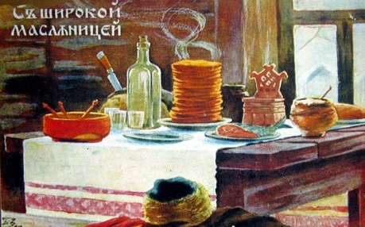

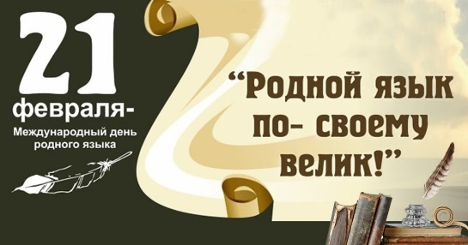
36. ORTHODOX CHRISTMAS 39. RUSSIAN LANGUAGE DAY
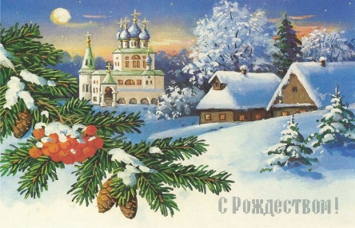

37. ORTHODOX EASTER 40. SLAVIC SCRIPT AND CULTURE DAY
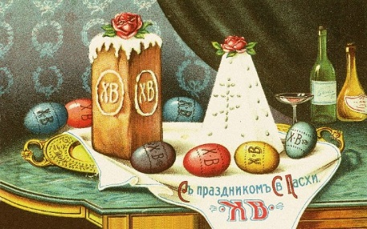
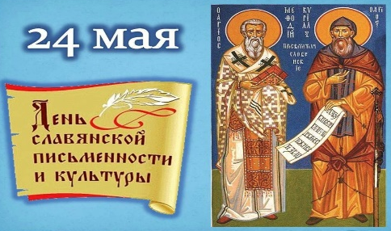

35 | 36 | 37 | 38 | 39 | 40

WRITING

This man and his pet are wearing party hats for a reason. They are celebrating the dog's birthday! Do you or anyone you know celebrate a pet’s birthday? If so, how do you celebrate?

Write a post for your school’s website of 80-100 words giving tips on planning a birthday party for a favorite pet.

Remember to include the following:
- a headline for the post,
- a recommendation on the place of the party,
- a piece of advice on people and animals to invite
- some tips (2-3) on the menu of the party and fun activities

