КУБОК ГЛАВЫ ГОРОДА 2024 , 5 КЛАСС. ОЧНЫЙ ТУР
Задание 1 LISTENING.
Прослушайте текст “Summer Holidays in Sochi” и определите, какие из приведённых утверждений 1-10 соответствуют содержанию текста (1 – True), какие не соответствуют (2 – False) и о чём в тексте не сказано, то есть на основании текста нельзя дать ни положительного, ни отрицательного ответа (3 – Not stated). Запишите в поле ответа цифру 1, 2 или 3, соответствующую выбранному вами варианту ответа.
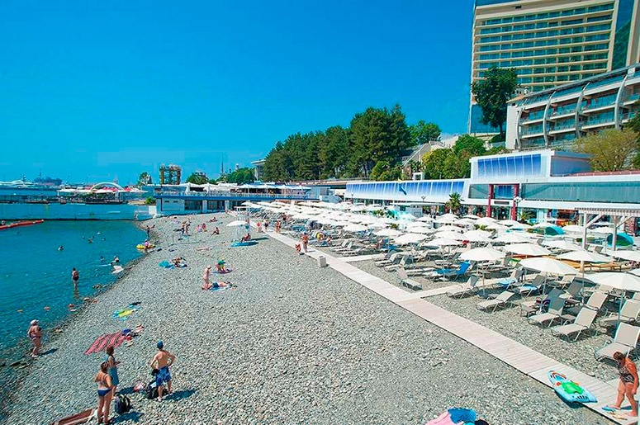
- The beaches in Sochi are cleaner than in Australia.
- There are big stones on the sea bottom.
- Because of stones, it’s hard to get into the water.
- Children play with jelly-fish in the sea.
- Sun-chairs are free for the people on the beach.
- A Promenade is a big supermarket.
- A boat trip in the sea is expensive.
- You can use a cable car to take a ride to the top of the Caucasus Mountains.
- You can try Thai and Chinese food in the restaurants.
- Tourists can get to Sochi by train and by plane.

1 | 2 | 3 | 4 | 5 | 6 | 7 | 8 | 9 | 10

Задание 2 READING. WINTER VACATIONS
Подберите заголовки к текстам о предстоящих зимних каникулах. Один заголовок – лишний. Запишите в таблицу выбранные ответы цифрами под соответствующими буквами.
The text deals with…
- VISITING COUSINS
- FAMILY TIME
- LEARNING A NEW ART
- STUDYING FOR MY FINAL EXAMS
- AMAZING ACTIVITIES
- HAVING AN OUTDOOR PARTY
- SPENDING TIME WITH GRANDPARENTS

- My Mum’s parents live in another city. We visit them during summer as well as winter vacations. We shall also be going to their place for a few days this year. I love their house. It is a huge house with a big lawn, beautiful trees, and plants. Visiting their place was the best part of the vacation. I always look forward to it.
12. My schedule is very hectic on the days when school is going on. I attend school, go to tuition classes and have to do my homework. I hardly get any time for self-study. Holidays are a good time to study. I am a morning person. I love waking up early in the morning, which is when I can focus easily. So I have decided to study for at least three hours each morning during my vacations.
- I am planning to visit my uncle’s children during these winter vacations. We have been planning this since they visited us during the summer break. We have a lot of plans for the few days I will be visiting them and are quite excited about the same. I am lucky to have like-minded guys. Being with them is the best feeling in the world.
- I also wish to indulge in some of my favourite activities during my winter vacations. I have already booked two classes a week for pottery. I will be going to the classes with my sister. I also plan to go for an evening walk regularly during my vacations. A stroll in the park during this time is simply refreshing. It is an awesome experience, and I don’t want to miss it at any cost.
- Apart from visiting my cousins and spending time with my family, I also plan to learn something new during my winter vacations. Glass painting has always fascinated me, and I wish to learn this art during this time. One of my aunts is also skilled in glass painting. I plan to visit her a few times to learn this skill. I have already brought the colours, brushes and frames and can’t wait to begin these sessions.
- I also want to spend time with my nearest and dearest. I am so tied during the usual school days that I can hardly spend time with my family. It has been a long that I sat with my grandparents and listened to their interesting stories. I want to spend a lot of time with them during the vacations. I also want to play with my baby sister. Besides, I will help my mother with the household chores as much as possible.
11 | 12 | 13 | 14 | 15 | 16

Задание 3 GRAMMAR
Autumn is one of the four major seasons in a year. Autumn changes the season from summer to winter because it falls between them. Autumn falls at different time in different part of the Earth.
In our country, this season falls from the month of September to November. Every season has its own features. Autumn is also known as ‘fall’ because the leaves from the trees start falling in autumn. Due to lack of rain, leaves start drying up and then they fall and the new l
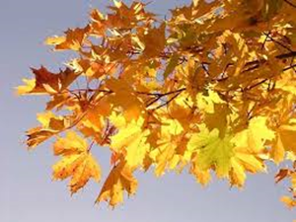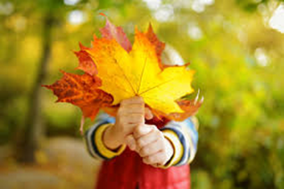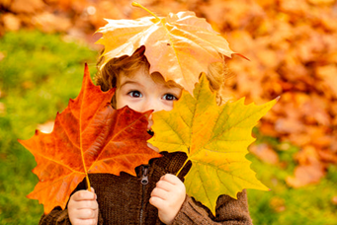
In autumn everything turns from green to yellow. Trees and grass become yellow in colour and the fallen 17_________cover the face of the earth. Autumn has _18_______own unique beauty.
Animals start preparing for winter in this season. Some birds like Cuckoos migrate to 19______ places. Small animals like squirrels and mouse start storing food. In winters, they do not come out from their holes and eat the stored food only. Animals like Bears, Turtles find a warm place where they can hibernate in winter.
Autumn season is a great season for growing vegetables and fruits. Carrot, Cauliflower, Beans, Apples, Grapes, Oranges are the gifts of this season. In our country, festivals like Durga Puja and Garba _20________ in autumn. This season shows a totally new face of nature. The weather in this season is loved by all because it is moderate. Autumn season _21______us that even if the leaves fall, new leaves _22_____ their place one day.
17) 1) leaf 2) leafs 3) leafes 4) leaves
18) 1) its 2) it is 3) it 4) it’s
19) 1) warming 2) warmest 3) warmer 4) more warm
20) 1) is celebrated 2) are celebrated 3) celebrated 4) celebrate
21) 1) teach 2) taught 3) teaches 4) is taught
22) 1) take 2) took 3) have taken 4) will take

Задание 4 VOCABULARY
Вставьте в пропуски подходящие по смыслу слова
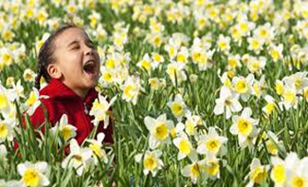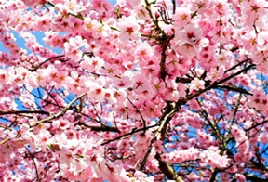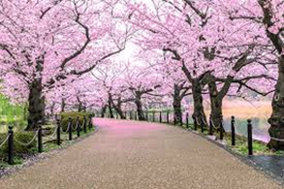
1 | festivals | 6 | poets
2 | singing | 7 | happiness
3 | butterflies | 8 | cloudless
4 | grass | 9 | sounds
5 | winter | 10 | summer
Spring season is the best and most favorite season of the year. People (especially kids) are fond of this season because of its beauty, slight cool and comfortable nature. It is the queen of all seasons of the year and considered as the favorite season of the 23 _____. It comes after 24______ season and before 25_____ season. It begins from the month of March and ends in the month of May. On the arrival of spring season everything on the earth looks adorable and charming. All the trees gets new clothes in the form of new leaves, flower starts blooming and fragrancing, birds start dancing and 26_____ on the tree branches, the sky becomes clear, 27 _______ and blue, fields become full of green 28_____ and other so many changes occur in the nature.
Spring season is the season of flowers and 29 _____ thus brings lots of joy and 30 _____ Colorful and beautiful flowers completely win the heart and green grasses give us a nice ground to walk in the garden. Beautiful flying 31______ catch our eyes often in the morning and evening. Day and night both become very pleasant and cool. Environment becomes full of charming 32_____ of bees, cuckoo, and other birds in the early morning.
23 | 24 | 25 | 26 | 27 | 28 | 29 | 30 | 31 | 32

Задание 5 QUIZ “HOLIDAYS IN RUSSIA”
В каждом месяце граждане России отмечают государственные, праздники и памятные даты. Совмести названия месяца с праздником, который в нём отмечается.
Заполни таблицу ответов
33 | January | 1 | The Day of Knowledge
34 | February | 2 | Teacher’s Day
35 | March | 3 | Orthodox Christmas
36 | April | 4 | Russian Flag Day
37 | May | 5 | Day of Family, Love and Fidelity
38 | June | 6 | People's Unity Day
39 | July | 7 | International Women’s Day
40 | August | 8 | New Year’s Day
41 | September | 9 | Cosmonautics Day
42 | October | 10 | The Day of Russia
43 | November | 11 | The Victory Day
44 | December | 12 | Defender of the Fatherland Day

33 | 34 | 35 | 36 | 37 | 38 | 39 | 40 | 41 | 42 | 43 | 44

WRITING
Задание 6 WRITING
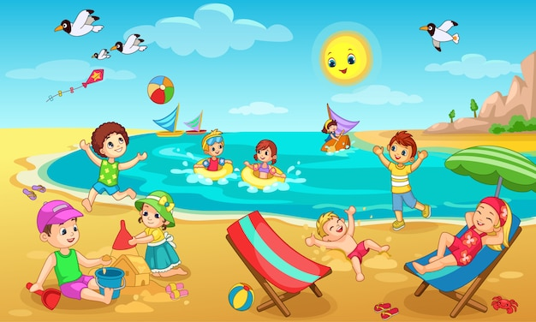
Напиши заметку в школьную стенгазету о пляжном отдыхе.
Воспользуйся предложенным планом. Не забудь написать вступление и заключение.
Объём заметки 60-80 слов.
PLAN:
- why beach holidays are popular in our country
- what kind of weather is good for a beach holiday
- what children and grown-ups can do on the beach
- who you would like to spend these holidays with
Используйте следующие слова: WAVES, SEAGULLS, SANDCASTLES, LUNCH BASKETS, BEACH VOLLEYBALL
BEACH HOLIDAYS IN RUSSIA
______________________________________________________________________________________________________________________________________________________________________________________________________________________________________________________________________________________________________________________________________________________________________________________________________________________________________________________________________________________________________________________________________________________________________________________________________________________________________________________________________________________________________________________________________________________________________________________________________________________________________________________________________________________________________________________________________________________________________________________________________________________________________________________________________________________________________________________________________________________________________________________________________________________________________________________________________________________________________________________________________________________________________________________________________________________________________________________________

