Задания муниципального этапа олимпиады
младших школьников по английскому языку
(2013-2014 уч. год, 3-4 класс)

Задание 1. Help Santa to match the countries with their capitals. Помоги Санта-Клаусу определить столицы этих стран. Соедини название страны и её столицы. Запиши столицу напротив каждой страны в бланке ответов

Задание 2. Read and write only ordinal numerals. Прочитай числительные, записанные транскрипционными знаками, и выпиши в бланк ответов те из них, которые являются порядковыми, их шесть! (№№ 8-13 в бланке ответов)

[wʌn], ['sevn], [fif'ti:n], ['twentiθ], [fo:θ], ['forti], ['fifti], [I'levn], [twelfθ], ['sekənd], [θə:d], [fə:st], ['sIkstI]

Задание 3. Choose the right variant and put it in the answer sheet.
Выберите правильный вариант и запишите в бланк ответов под соответствующим номером

14. ..... he watch TV in the evening?
a) Is b) Do c) Does
15. He ..... read French books.
a) doesn’t b) don’t c) isn’t
16. She sometimes ..... basketball.
a) to play b) play c) plays
17. She wants ..... basketball.
a) to play b) play c) plays
18. She can ..... basketball.
a) to play b) play c) plays
19. ..... know his telephone number?
a) You b) Do you c) Are you
20. They ..... buy newspapers.
a) not b) don’t c) doesn’t
21. ..... read English books?
a) Can she b) She can c) Is she
22. The cat cannot see ..... kittens.
a) it’s b) its c) her
23. Where .....?
- the tiger is b) is the tiger c) does the tiger
24. – Is he from England?
a) – Yes, he does. b) – Yes, he has. c) – Yes, he is.
25. – Are they English?
a) – Yes, they are. b) – Yes, there are. c) – Yes, they English.
26. – Do they often sing English songs?
a) – No, they do. b) – No, they do not. c) – No, they doesn’t.
27. – Did he sing an English song?
a) – Yes, he sing. b) – Yes, he sang. c) – Yes, he did.

Задание 4. One word doesn’t match the others in each line. Write it in your answer sheet. 1 словo в каждой строке не подходит к остальным. Найди и выпиши его в бланк ответов

28. Italy, Russia, Spain, Africa, Canada …………………………….……
29. A bath, a hall, a sitting-room, a living-room, a kitchen …………..….
30. English, French, German, Spanish, British …………………………..
31. A shelf, a table, an armchair, a window, a sofa ………………….……
32. A teacher, a reader, doctor, a dentist, an engineer ……………………
33. Run, swim, play, jump, song ………………………………………….
34. Hopscotch, tag, leapfrog, darts, merry-go-round ……………………..
35. Beautiful, funny, strong, well, short ………………………………….

Задание 5. Read the text and answer the questions. Прочитай текст и ответь на вопросы

My name is Ann and I’m twelve years old. My favourite room is my bedroom. I’ve got lots of things in my room: a bed, a computer, a bookcase and a wardrobe. I’ve got posters on the walls and a big mirror in front of my bed. My walls are pink, orange and white. My desk is next to the window and I do my homework on the computer. My dog Jasper likes to sleep under my bed, he always does it! I really like my room!

- What is her favourite room? _________________________________
- What is on the walls? ______________________________________
- What colour are the walls?___________________________________
- Where is the desk? ________________________________________
- What is always under her bed? _______________________________

Задание 6. Choose the sentences which are true to the picture. Выбери предложения, соответствующие картинке. Выпиши их номера через запятую в бланк ответов

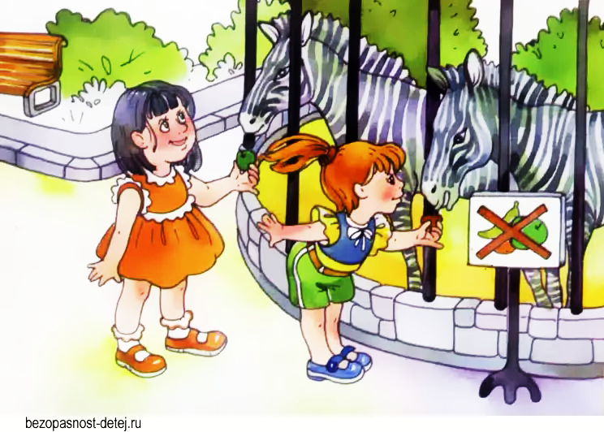
- It is winter.
- The girls are at the Zoo.
- The children are wearing light clothes.
- They are looking at the donkeys.
- You mustn’t feed the animals at the Zoo.
- The girls follow the rules.
- They give cookies to the animals.
- The animals live in cages at the Zoo.
- The animals live free at the Zoo.
- The zebras are friendly.

Итого 50 баллов

